First, run the code to generate two certificates, x509_keyGen.py . You will then have two PEM files, csr.pem and rsakey.pem. Then run the key_load.py program to actually load the generated private RSA key into the system and use it to sign the CSR.

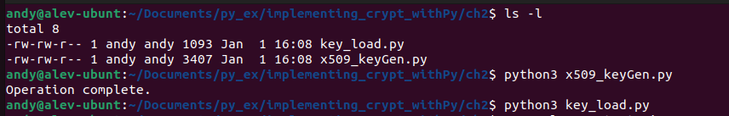

Then, the openssl shell command is used to view the full CSR shown below.

